Handout no. 3

|  |  |
| --- | --- |
| **Name** | Ahmad Bandesha, Faizan Azam, Muhammad Asad |
| **Reg. No** | 2019-EE-373, 2019-EE-381, 2019-EE-383 |
| **Marks/Grade** |  |

**EXPERIMENT # 3**

**Analysis of multivariable power system using Newton Raphson Method**

**Objective:**

At the end of this lab session students will be able to

* To design Power system operations in in Power World Simulator.
* To observe power flow in power System.

**Introduction:**

Newton Raphson Method is an iterative technique for solving a set of various nonlinear equations with an equal number of unknowns. It is one of the most important tools for determining the optimal solutions of many problems in different areas The Multi-variable Newton-Raphson method is a direct extension of the single variable Newton- Raphson method. Where the single variable Newton-Raphson method solved f (x) = 0, the multivariate version will solve a system of n equations of the form

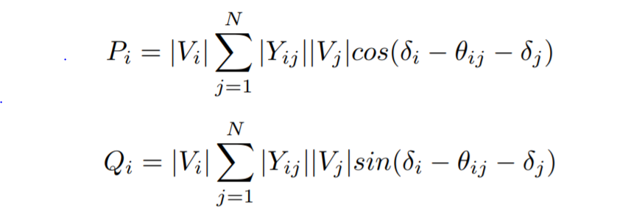

There are two methods of solutions for the load flow using Newton Raphson Method.

* + The first method uses rectangular coordinates for the variables.
  + The second method uses the polar coordinate form.

Out of these two methods the polar coordinate form is widely used.

**Using PWS**

* Draw the one-line diagram in PWS.
* In the Run Mode, go to Tools → Solve → Polar Newton Raphson Power Flow. This
* will give you the final result of the bus voltages after performing all the iterations.
* To view the mismatch vector in PWS go to Case Information → Solution Details →Mismatches.
* Corroborate your theoretical result with this mismatch vector. Note you may have calculated the mismatch vector in per units but PWS displays the result in physical units. So, you may need to accommodate the multiplying factor.
* To the Jacobian matrix in PWS go to Case Information Solution Details →Power Flow Jacobian. Corroborate your theoretical result with this Jacobian matrix.
* You can also import this Jacobian matrix into MATLAB. Go to Application button and select Save Y-bus or Jacobian.
* To check your results iteration by iteration, go to Tools → Simulator Options →Common Options → Check 'Do Only for One Iteration'. Now repeat the above step to get results for each iteration.
* While doing single iterations you will hear warning sounds until the solution converges.
* The detailed results of each iteration can be viewed through log in the Tools selection.

**Simulations:**

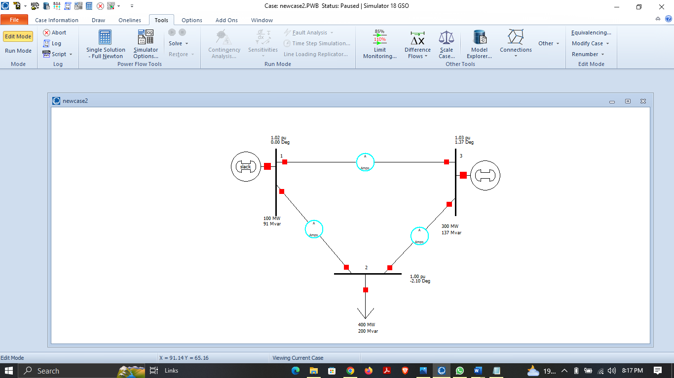

**Figure 3.1:** **Three Bus Power System in Edit Mode**

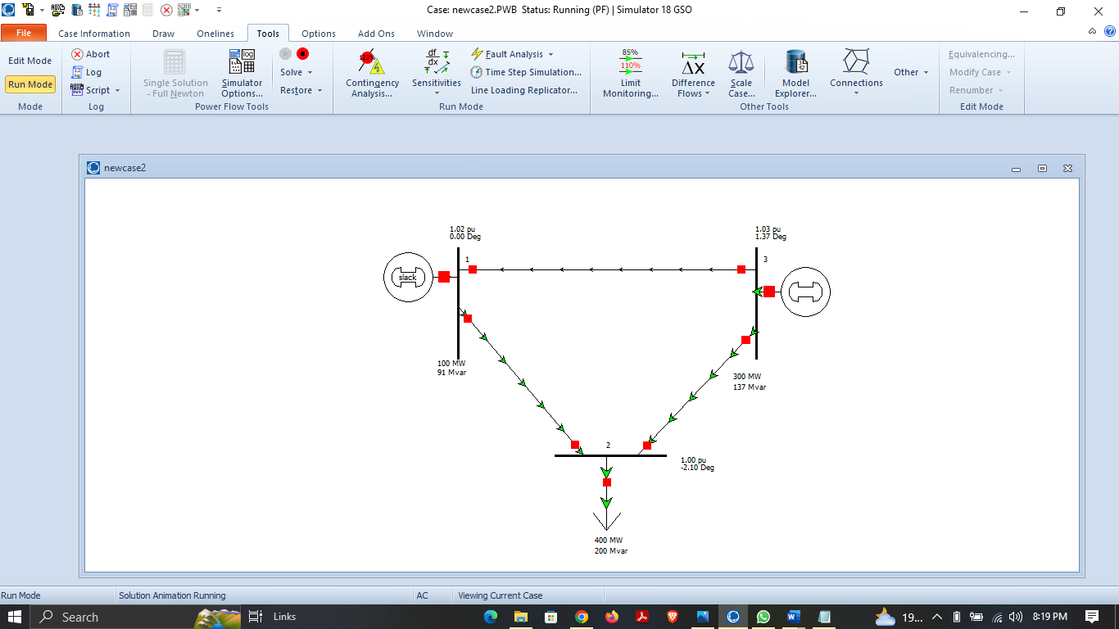

**Figure 3.2:** **Three Bus Power System in Run Mode**

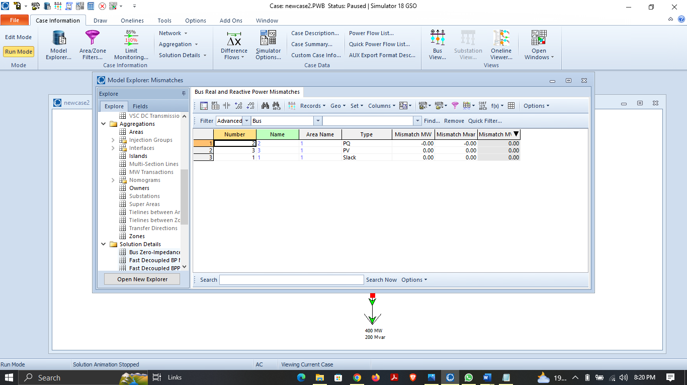

**Figure 3.3: Mismatches**

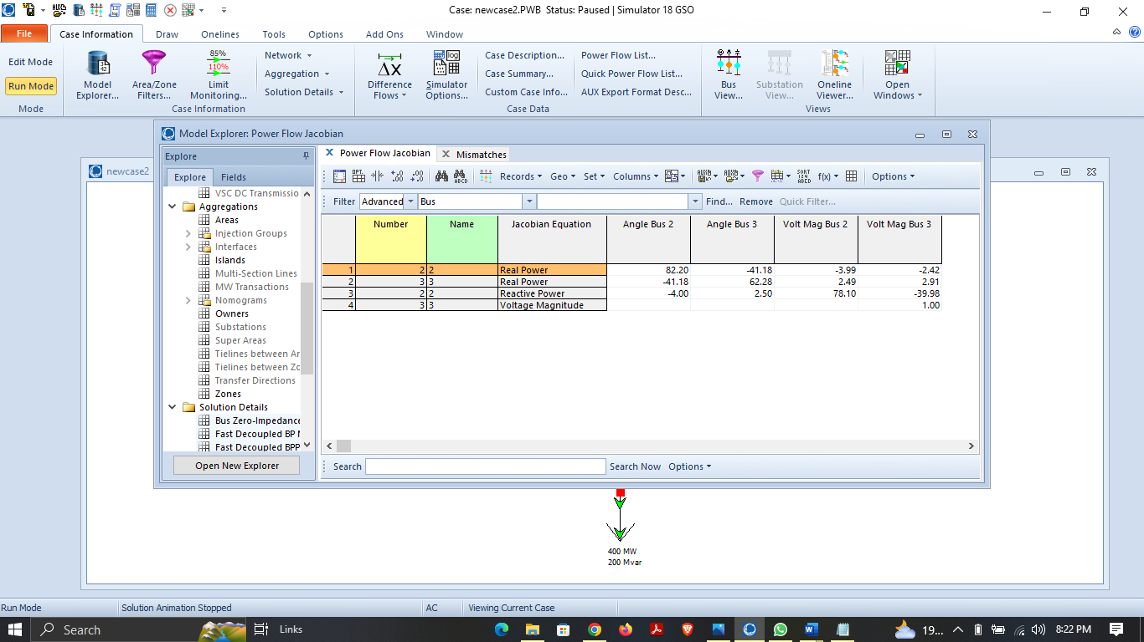

**Figure 3.4: Jacobian Matrix of three Bus System**

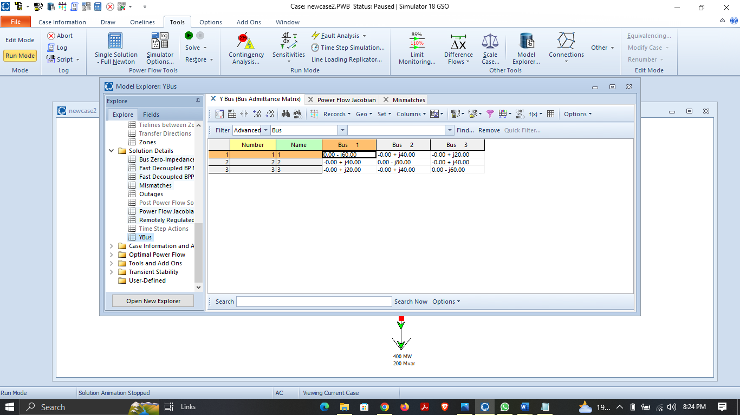

**Figure 3.5:** **Characteristics of three bus power system network**

* 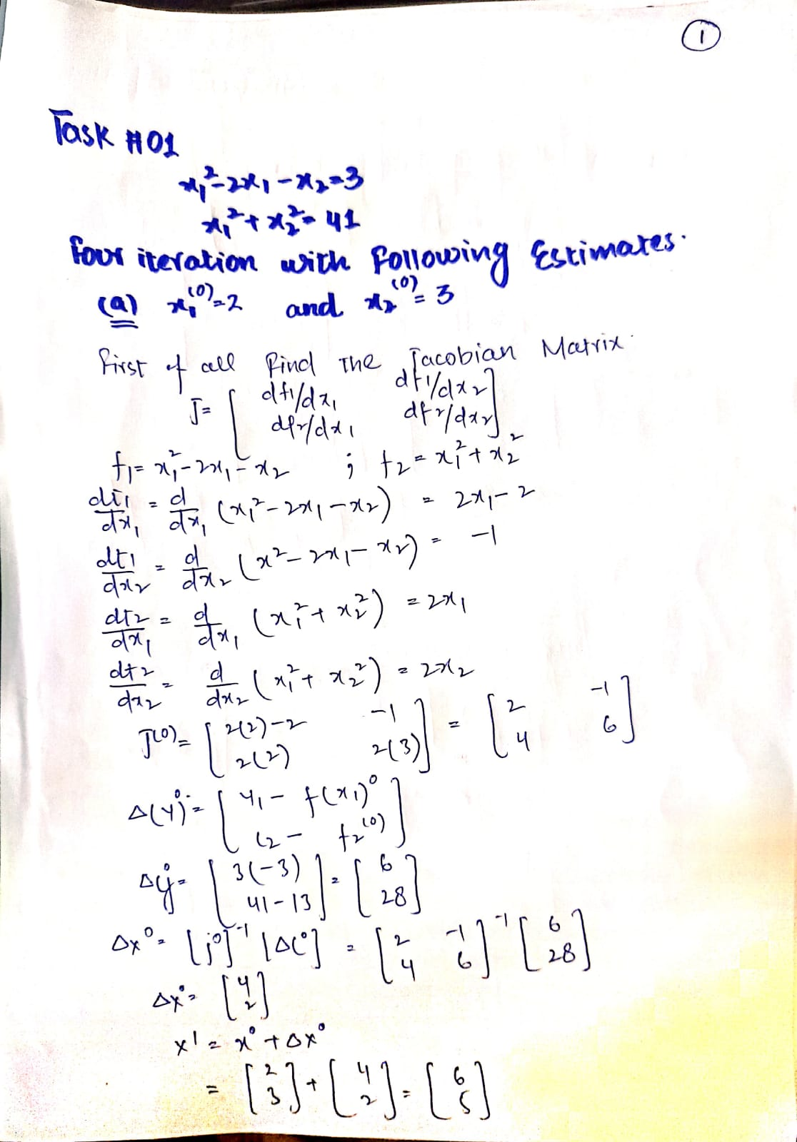**Mathematical Calculations:**

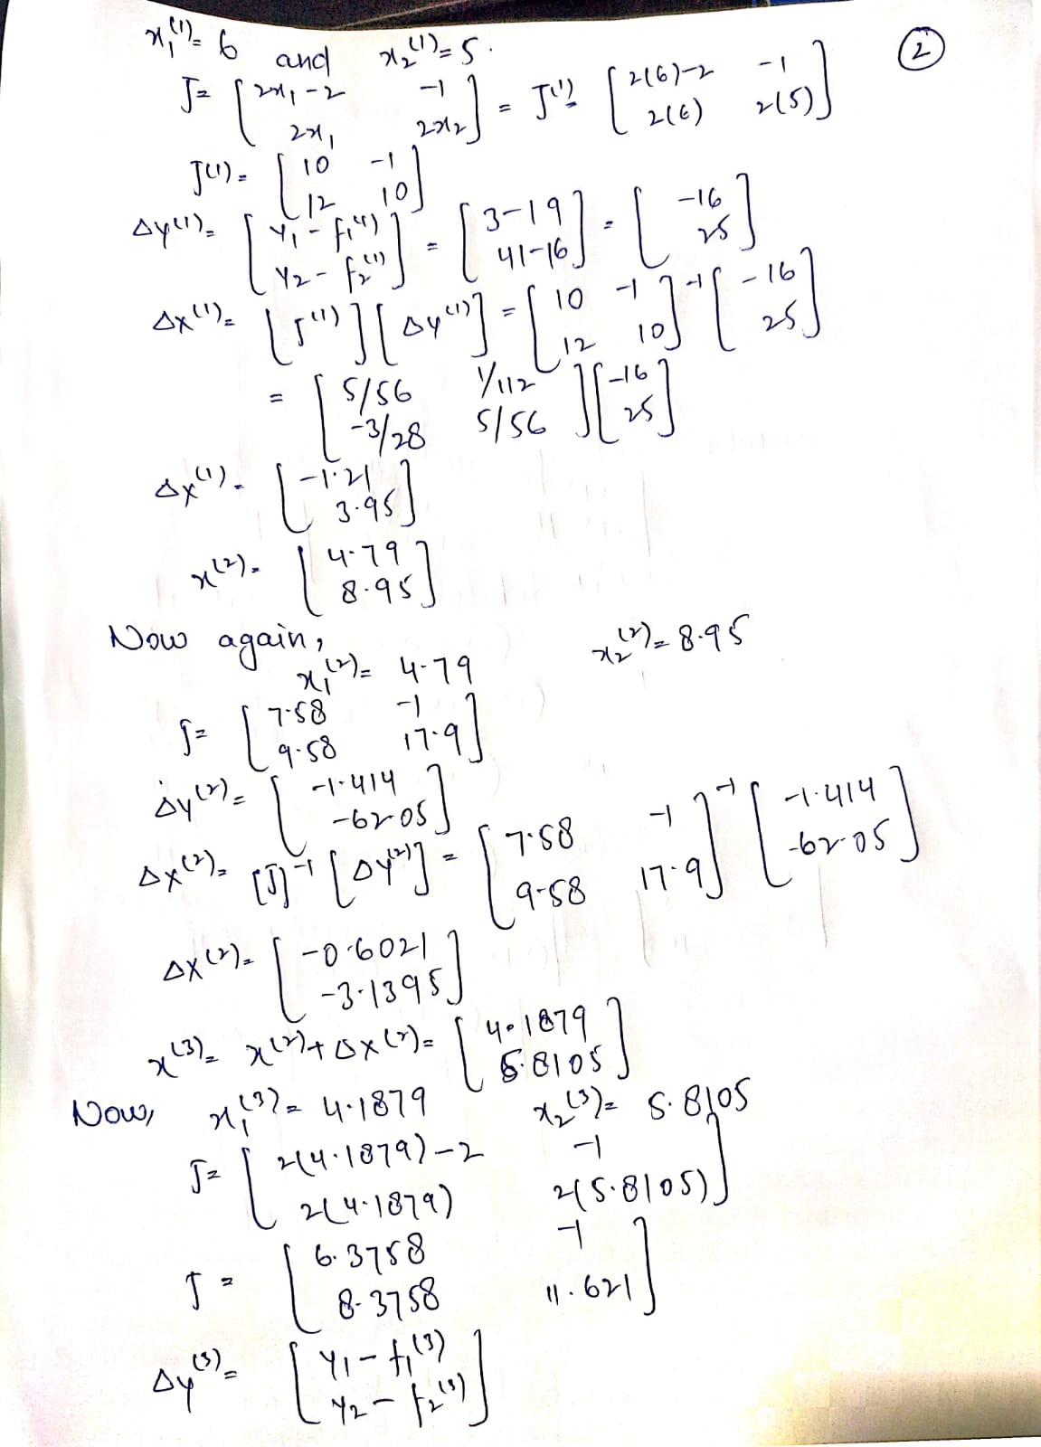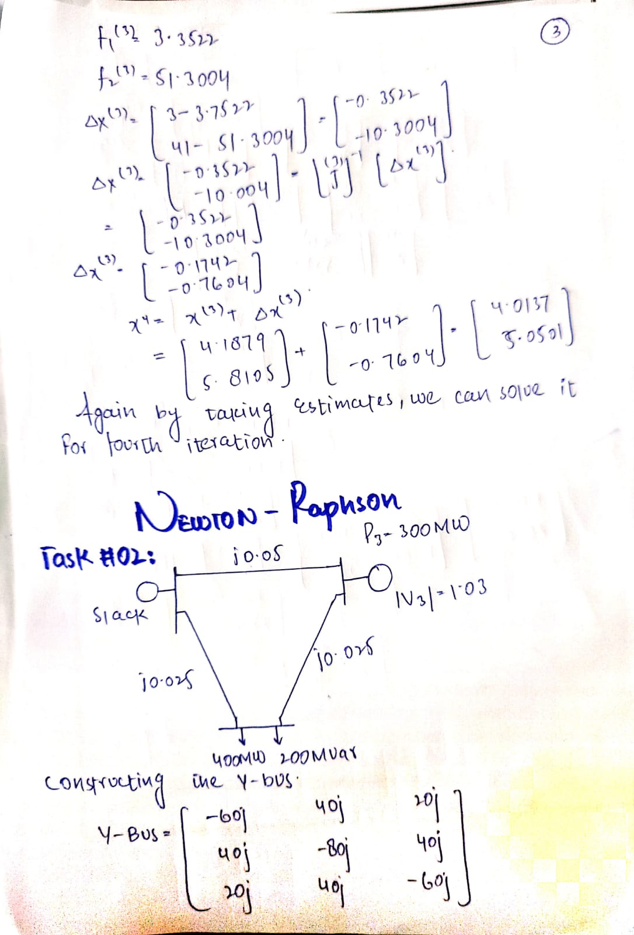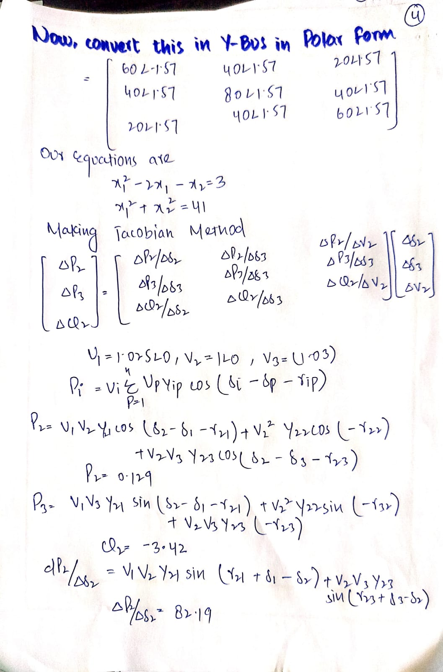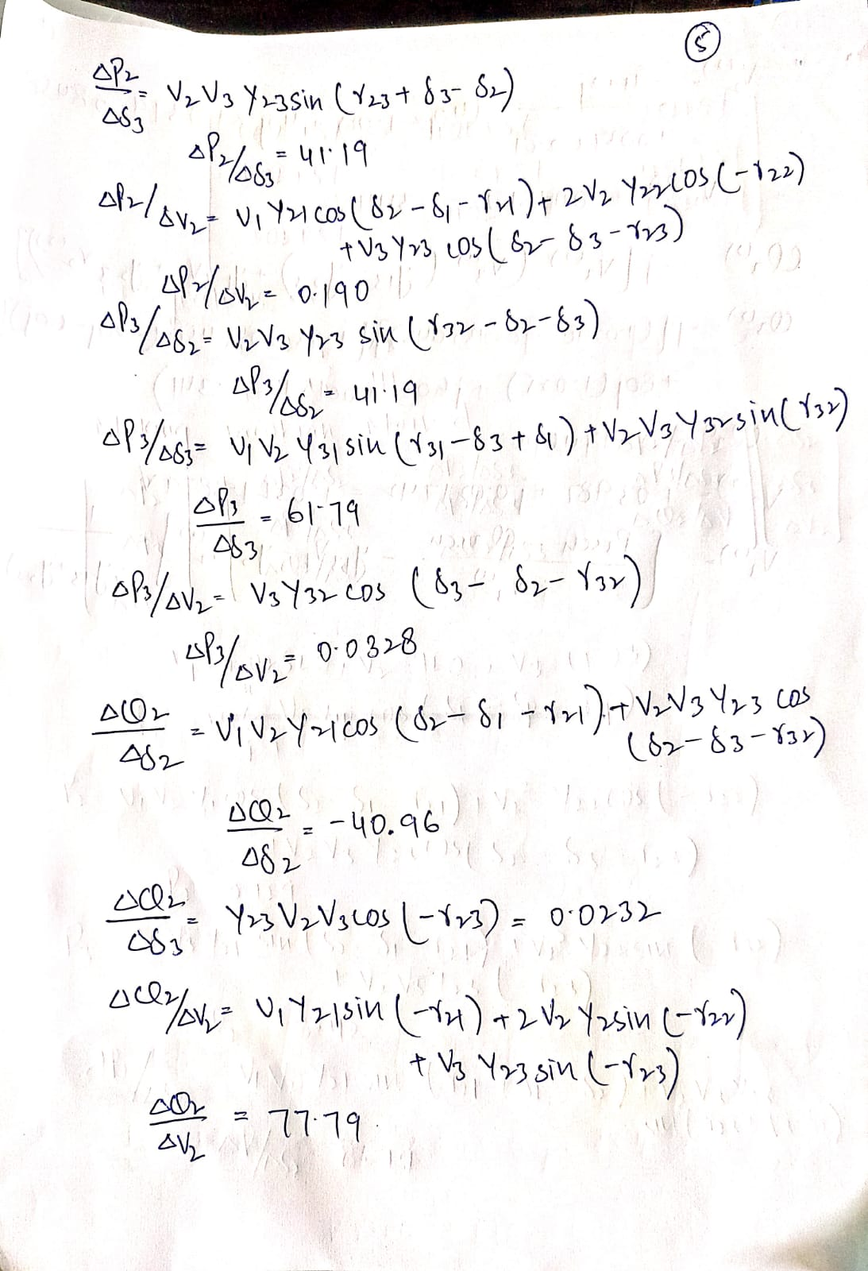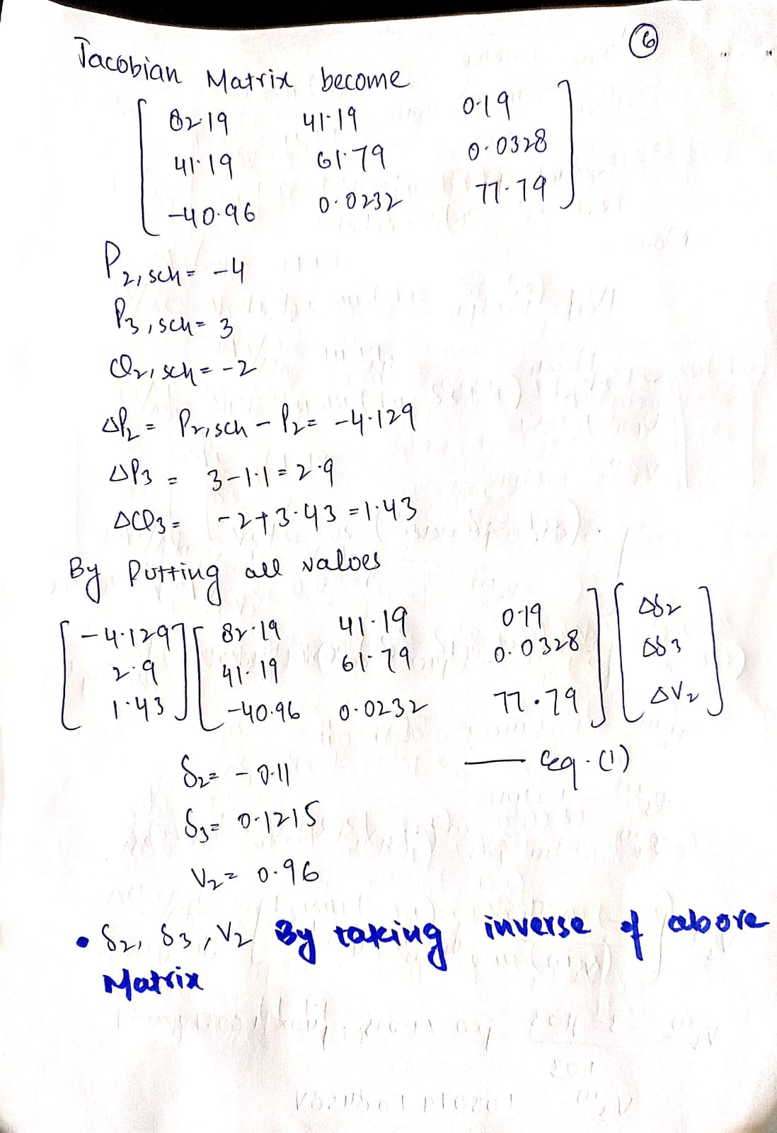

* **Comparison Table:**

|  |  |  |  |  |  |
| --- | --- | --- | --- | --- | --- |
| **No. of iterations** | **Calculations** | | **PWS** | |  |
| **Voltages (pu)** | **Angle** | **Voltages (pu)** | **Angle** |
| 1st Iteration | 1.03748 | -2.08 | 0.96 | -2.6 |
| 2nd Iteration | 1.00131 | -2.3411 | 1 | -2.10 |

**Table: 3.1 For Bus 2**

|  |  |  |  |  |
| --- | --- | --- | --- | --- |
| **No. of iterations** | **Calculations** | | **PWS** | |
| **Voltages (pu)** | **Angle** | **Voltages (pu)** | **Angle** |
| 1st Iteration | 1.03079 | 0.8458 | 0.98 | 1.17 |
| 2nd Iteration | 1.03 | 1.3879 | 1.03 | 1.37 |

**Table: 3.2 For Bus 3**

**Comments & Observations:**

The Newton Raphson Method is one of the most commonly used techniques for finding the roots of given equations. It can be efficiently generalized to find solutions to a system of equations. Moreover, it shows that when we approached the root, the method is quadratically convergent. The method is very simple to apply and has great local convergence. Another disadvantage is that we must have a functional representation of the derivative of our function, which is not always possible if we working only from given data. Moreover, in this model it was observed that when transmission line reactance is included, more reactive power is withdrawn from Slack Bus.